**Logo**

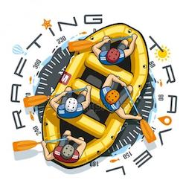

## ****Color Palette****

The following are the chosen colors for the rafting site, including their hexadecimal (hex) codes:

|  |  |
| --- | --- |
| * **Primary** | * 669bbc |
| * **Secondary** | * 003049 |
| * **Accent 1** | * fdf0d5 |
| * **Accent 2** | * 003049 |

**Color Palette URL:https://coolors.co/palette/780000-c1121f-fdf0d5-003049-669bbc**

## ****Typography****

The selected fonts for the website are:

**Nunito+sans**

Lato

**Heading Font:**

**Nunito+sans**

**Text Font:**

**Lato**